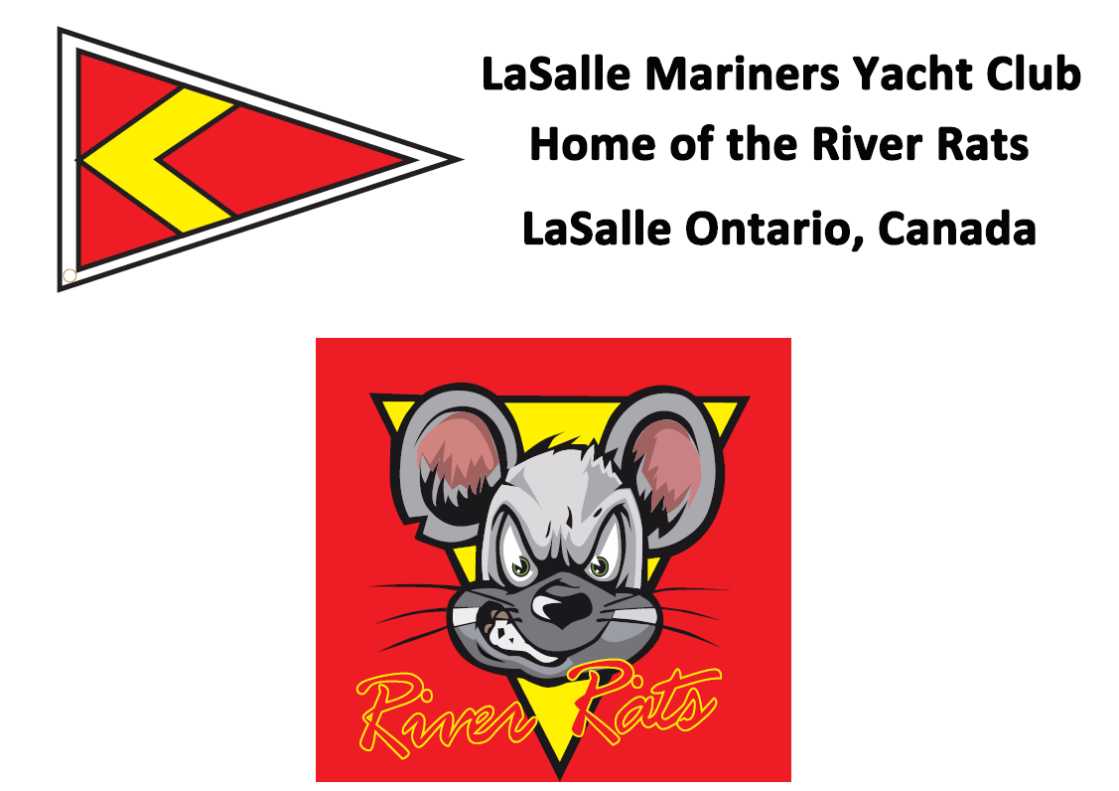
Notice of Race & Sailing Instructions
LMYC River Rat Race
Saturday October 15, 2022

Come one, come all to your club’s River Rat Race to officially end the season! Racers are invited to don their wooly underwear if necessary to dispatch 2022 into the history books. Each person attending is encouraged to bring a dish to share.

Registration & Racing

Each skipper is required to register their boat. A registration form makes part of these instructions and copies will be available in the clubhouse prior to race start.
Please register your boat in a choice of PHRF, JOG or Shorthanded based on ratings.
EC PHRF or recognized ratings will be used create classes within each division and used in scoring to declare our Rat Winners.
In the end it isn’t about winning or losing but having fun with our LMYC Family and Friends.
The race is free!
5 blasts of the horn will be a warning at 11:54 am will alert racers to prepare to countdown with the first race sequence horn sounding at 11:55 a.m. and the yellow flag hoisted and PHRF “A” entries leading the way. There will be a short Skipper’s meeting at 10:45 a.m. in front of the clubhouse

Class Rating Pennant Colour
- PHRF A 125 & lower Yellow
- PHRF B 126-175 Green
- PHRF C 176 and Higher Orange
- JAM A 199 & lower White
- JAM B 200 & Higher Pink
- SHORTHANDED 2nd Yellow
Class flags (not smaller than size 6”x6”) shall be displayed from the aftermost backstay at least 6 Feet above the deck. This is a fun race, no protests will be accepted, but please be honest if you mess up.

Course: The start will be between an orange flag on the committee boat and a mark located just south of Buoys DF15 + DF16.
Proceed south to DF1, leaving to starboard, then to D84 leaving to starboard. Head North (approximate) to D104 leaving to starboard. Then head south ( approximate) sailing between fighting Island and Canadian Grassy Island to DGB, leaving to port.
The finish line, located near LaSalle Mariners - HOME OF THE RIVER RATS - will be between and orange mark and the Committee Boat.

Shortened Course(not on the map): If weather is inclement, we’ll use our normal club race starting line and we’ll use a club race course 1 or 2 ending at DF8 or DGB. We’ll decide if this comes into effect at the Skipper’s meeting.

The Race Committee has the authority to shorten the course as necessary and will fly the “Sierra” flag to advise all racers.

Have FUN, Sail FAST, RESPECT your fellow competitors and Be SAFE.

2022 River Rat
Registration Form
- CLASS/MAKE OF YACHT __________________
- YACHT NAME ______________________
- SAIL NUMBER _____________________________
- LARGEST HEADSAIL (overlap%)_____________
- OWNER (SKIPPER) _________________________
- PHONE: RES/ CELL NO: ____________________
Competing in:
Spinnaker Division Rating _______
JAM Division Rating _______
Short Handed Division Rating _______
E-MAIL ADDRESS __________________________
Insurance Provider (for Non LMYC participants): __________________________

Agreement to assume risks and hold harmless.

In consideration of being permitted to enter this race, all contestants, crewmembers and guests aboard, voluntarily assume the risk of participating in this race and post-race activities. I accept this statement. Please initial here:______
I agree:
(a) to hold harmless against loss, the organization and personnel conducting this race;
(b) to be respectful towards the Racing Rules of Sailing while having fun during this event:
(c) The Yacht is fully Insured

Owner’s Signature: _______________________________ Date: ________________
Please return all registration forms to the Race Director mailbox prior to the Skipper's meeting the day of the race.

